3 ReactJS-HOL-HANDS-ON-ANSWERS
We create the React application using the following command in the VS Code terminal –
A new folder named “Components” has been created under the ‘src’ folder which consists of the “CalculateScore.js” file.
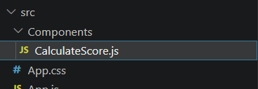
Then we write the following code inside the CalculateScore.js file –
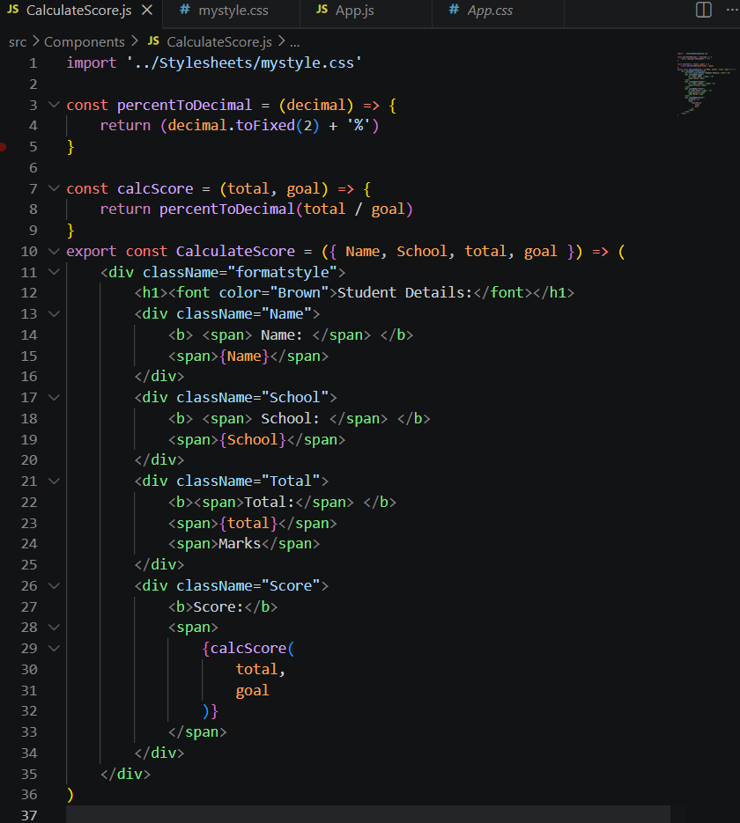
“mystyle.css” has been added under “Stylesheets” folder under “src” folder
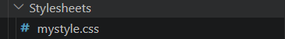
Code in “mystyle.css” is written as follows:
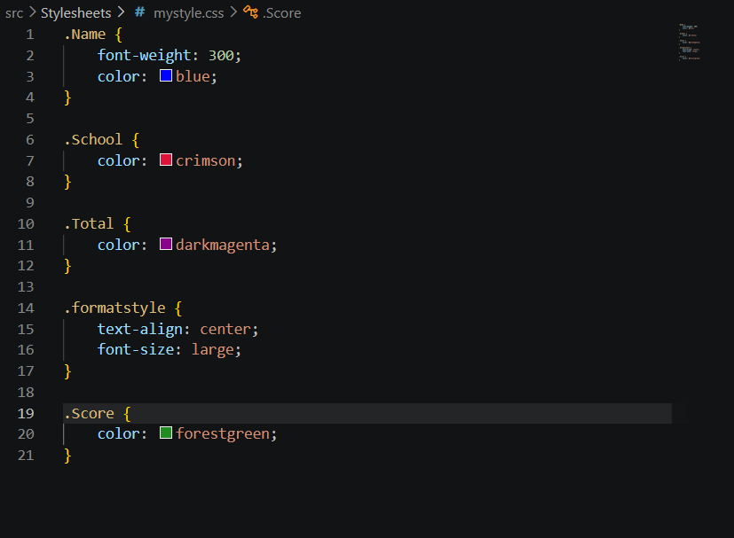
And lastly the “App.js” has been updated as –
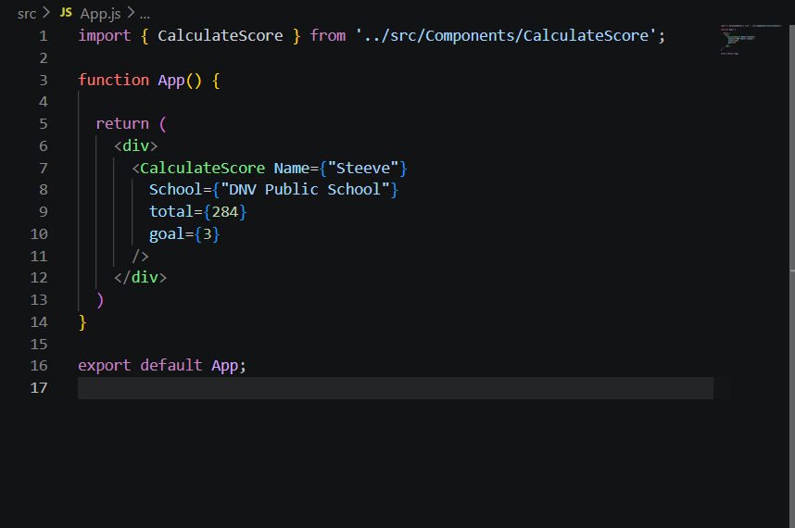
Now in the command prompt –
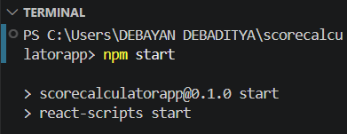
And the result is shown here –
